# C2- S6 - PRACTICE

*NOTE: check your* ***THEORY slides*** *to answer those questions!*

# EXERCISE 1 – DISCOVER ON DELETE CASCADE STATEMENT

We want to manage Student and Class:

* A student always has one class (Example: Lyhour is in WEP B)
* A class can have many students (Example: WEP A has all the second-year girls)

**PART 1 – WITHOUT <ON DELETE CASCADE>**

|  |
| --- |
| CLASS |
| class_id |
| name |

|  |
| --- |
| Attribute name |
| student_id |
| first_name |
| last_name |

**Q1** - What is the relation between Student and Class table?

Relation between Student and class is relation many to one.

**Q2 -** Complete the missing attribute in the Student table.

|  |
| --- |
| Attribute name |
| student_id |
| first_name |
| last_name |
| Class id |

**Q3 -** For each table, complete the following arrays, by specifying for each attribute:

* + The attribute type (SQL type) and size
  + Can be null or not?
  + Is a primary key or foreign keys?

**CLASS TABLE**

|  |  |  |  |
| --- | --- | --- | --- |
| Attribute name | Type / size | Null? | Key |
| class_id | Int(11) | No | PK |
| name | Varchar(50) | Yes |  |

**STUDENT TABLE**

|  |  |  |  |
| --- | --- | --- | --- |
| Attribute name | Type / size | Null? | Key |
| student_id | Int(11) | No | PK |
| first_name | Varchar(50) | Yes |  |
| last_name | Varchar(50) | Yes |  |
| class_id | Int(11) | No | FK |

**Q4** - Write the SQL statement to create the 2 tables with appropriate properties

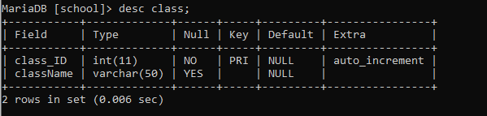

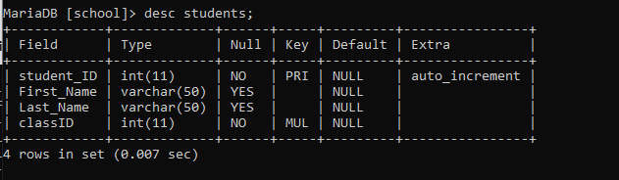

**Q5 –** Write the statement to insert the following classes and students

Notes:

* We don’t specify the KEY, it’s your business!

**CLASS**

|  |
| --- |
| Name |
| WEP A |
| WEP B |
| SNA |

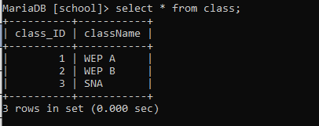

**STUDENT**

|  |  |  |
| --- | --- | --- |
| First Name | Last Name | His/her class |
| Lyhour | Ngorn | WEP B |
| Koem Sak | Mean | WEP B |
| Kunthy | Sen | WEP A |
| Channary | Pha | WEP A |
| Chanthy | Tha | WEP B |

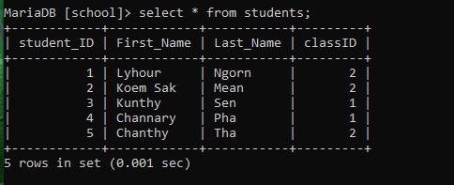

**Q6 –** Write the statement to delete the class WEP A

* What happens? Can we delete it? Why?

**We cannot delete the class WEP A because the column WEP A is the foreign key of students table.**

**PART 2 – WITH <ON DELETE CASCADE>**

**Q7 -** Write the statement to delete the table student

**Q8 –** Write the statement to create again the table student, but this time, you need to add ON DELETE CASCADE next to the line where you reference the foreign key class_id.

Like in this example:

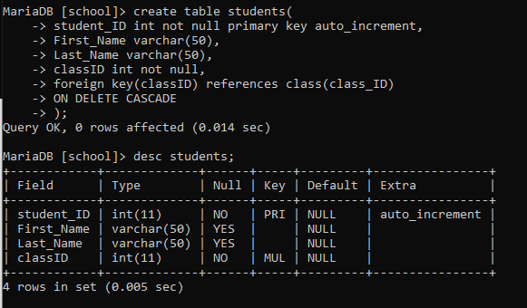------------------------------------------------------------------------

CREATE TABLE hard_candy

(candy_num INT,

candy_flavor CHAR(20),

FOREIGN KEY (candy_num) REFERENCES all_candy ON DELETE CASCADE);

------------------------------------------------------------------------

**Q9 -** Write the statement to insert again the following students in the student table (same statement as Q5).

**STUDENT**

|  |  |  |
| --- | --- | --- |
| First Name | Last Name | His/her class |
| Lyhour | Ngorn | WEP B |
| Koem Sak | Mean | WEP B |
| Kunthy | Sen | WEP A |
| Channary | Pha | WEP A |
| Chanthy | Tha | WEP B |

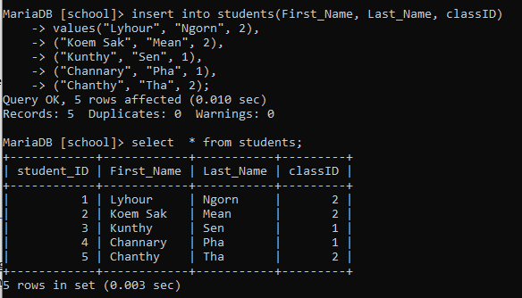

**Q10 -** Write the statement to delete the class WEP A

* What happens? Can we delete it?

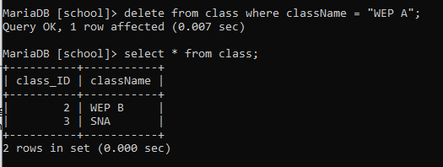

It does not alert error on another table. Yes, we can.

**Q11 -** Write the statement to show the data that is in the Student table. Try to understand why some students do not appear anymore.

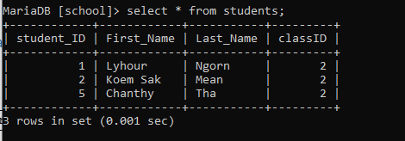

# Because we putted on delete cascade on the class_id that are the foreign key of students table and another records that are the children of parents.

# EXERCISE 2 – INTRODUCTION TO BOOLEAN DATA TYPE

In the following questions, you need to choose between the suggested answers which data type is the right one to use for the attribute. You need to use this webpage:

<https://www.w3schools.com/mysql/mysql_datatypes.asp>

and explain your answer each time.

**Q1 –** What is the best data type to use for the attribute **first name** of the entity **Student**

1. CHAR(50)
2. VARCHAR(50)
3. BOOLEAN
4. VARCHAR(3)

**Q2 -** What is the best data type to use for the attribute **completed** of the entity **Task**

1. VARCHAR(3)
2. INT(1)
3. BOOLEAN
4. BOOL

**Q3 –** What is the best data type to use for the attribute **duration** of the entity **Movie**

1. DATE
2. TIME
3. INT(3)
4. TIMESTAMP

**Q4 –** What is the best data type to use for the attribute **activated** of the entity **Traffic light**

1. INT(1)
2. BOOLEAN
3. CHAR(3)
4. BOOL

**Q5 –** What is the best data type to use for the attribute **passed** of the entity **Exam**

1. TIME
2. VARCHAR(5)
3. BOOLEAN
4. STRING

**Q6 –** What is the best data type to use for the attribute **date of birth** of the entity **Student**

1. TIME
2. DATE
3. DATETIME
4. INT(100)

# EXERCISE 3 – NEED TO UPDATE DATA OF AN EXISTING TABLE

|  |  |  |  |  |  |  |  |  |  |  |  |  |  |  |  |  |  |  |  |  |  |  |  |  |  |  |  |  |  |  |  |  |  |  |  |  |  |  |  |  |  |  |  |  |  |  |  |  |  |  |  |  |  |  |  |  |  |  |  |  |  |
| --- | --- | --- | --- | --- | --- | --- | --- | --- | --- | --- | --- | --- | --- | --- | --- | --- | --- | --- | --- | --- | --- | --- | --- | --- | --- | --- | --- | --- | --- | --- | --- | --- | --- | --- | --- | --- | --- | --- | --- | --- | --- | --- | --- | --- | --- | --- | --- | --- | --- | --- | --- | --- | --- | --- | --- | --- | --- | --- | --- | --- | --- |
| **CUSTOMER** | | | | | | | | | | | | | | | | | | | | | | | | | | | | | | | | | | | | | | | | | | | | | | | | | | | | | | | | | | | | | |
| **Name** | **Type** | **Description** |  |  |  |  |  |  |  |  |  |  |  |  |  |  |  |  |  |  |  |  |  |  |  |  |  |  |  |  |  |  |  |  |  |  |  |  |  |  |  |  |  |  |  |  |  |  |  |  |  |  |  |  |  |  |  |  |  |  |  |
| ID | INT(100) | A customer ID in the inclusive range *[1, 1000]*. This is the primary key. |  |  |  |  |  |  |  |  |  |  |  |  |  |  |  |  |  |  |  |  |  |  |  |  |  |  |  |  |  |  |  |  |  |  |  |  |  |  |  |  |  |  |  |  |  |  |  |  |  |  |  |  |  |  |  |  |  |  |  |
| NAME | VARCHAR(2) | A customer name. This field contains between *1* and *100* characters (inclusive). |  |  |  |  |  |  |  |  |  |  |  |  |  |  |  |  |  |  |  |  |  |  |  |  |  |  |  |  |  |  |  |  |  |  |  |  |  |  |  |  |  |  |  |  |  |  |  |  |  |  |  |  |  |  |  |  |  |  |  |
| COUNTRY | CHAR(10) | The country of the customer. |  |  |  |  |  |  |  |  |  |  |  |  |  |  |  |  |  |  |  |  |  |  |  |  |  |  |  |  |  |  |  |  |  |  |  |  |  |  |  |  |  |  |  |  |  |  |  |  |  |  |  |  |  |  |  |  |  |  |  |
| CREDITS | INT(1000) | The credit limit of the customer. |  |  |  |  |  |  |  |  |  |  |  |  |  |  |  |  |  |  |  |  |  |  |  |  |  |  |  |  |  |  |  |  |  |  |  |  |  |  |  |  |  |  |  |  |  |  |  |  |  |  |  |  |  |  |  |  |  |  |  |
| ACCOUNT ACTIVATED | BOOLEAN | Tells if the customer’s account is activated or not |  |  |  |  |  |  |  |  |  |  |  |  |  |  |  |  |  |  |  |  |  |  |  |  |  |  |  |  |  |  |  |  |  |  |  |  |  |  |  |  |  |  |  |  |  |  |  |  |  |  |  |  |  |  |  |  |  |  |  |

**Q1 –** Write the statement to create the **Customer** table with the appropriate properties

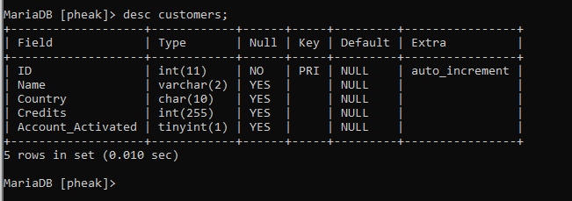

**Q2 –** Write the statement to modify the type of the column(=attribute) **Country** from CHAR(10) to VARCHAR (20)

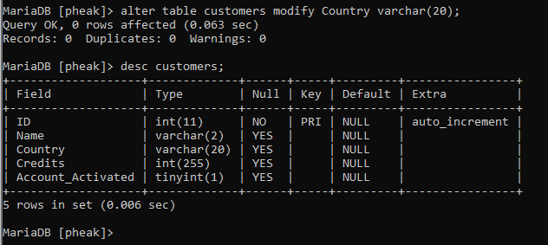

**Q3 –** Write the statement to modify the name of the column **Name** to **First Name**

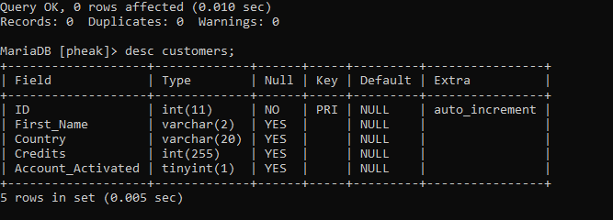

**Q4 –** Write the statement to modify the type of the column **First Name** from VARCHAR(2) to VARCHAR(50).

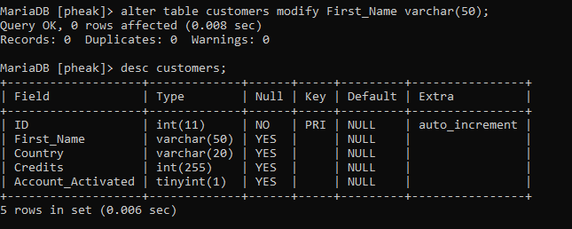

**Q5 –** Write a statement to add a new column to the table **Customer,** called **Last Name**

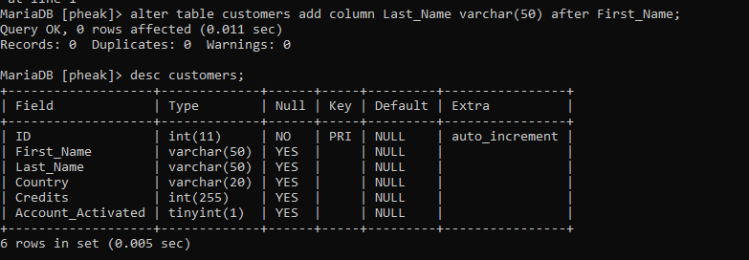

**Q6 –** Write a statement to insert all the following data in the table **Customer**

First Name – Last Name – Country – Credits – Account activated

-----------------------------------------------------------------------

Diane Reynolds UK 9260714 FALSE

Larry Burke USA 7414650 FALSE

Dennis Reid Singapore 2721484 FALSE

Joe Cruz Canada 7776372 FALSE

Robin Shaw Albania 4793116 FALSE

Donald Morrison China 1384666 FALSE

Eugene Hall UK 8910281 FALSE

Donald Gilbert Albania 6669850 FALSE

Samuel Harvey USA 5719094 FALSE

Robin Scott Singapore 6929083 FALSE

**Q7 –** All the customers from the USA now have their account activated: **write a statement to modify the data of the right records to take it into account.**

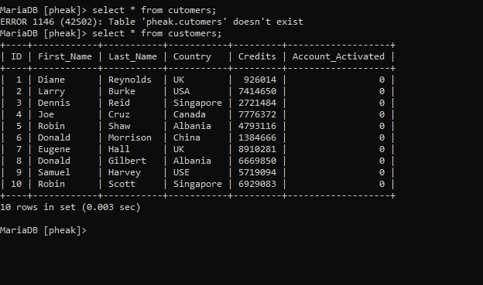

**Q8 –** Diane got married with Samuel so her last name changed from Reynolds to Harvey-Reynolds. **Write a statement to update the data in the right record.**

**Q9 –** The company does not work in the UK anymore so they don’t need the data of their former UK customers. **Write a statement to delete the records of the UK customers.**